GITLAB POC

**For running Gitlab pipeline we need to do some configurations on AWS**

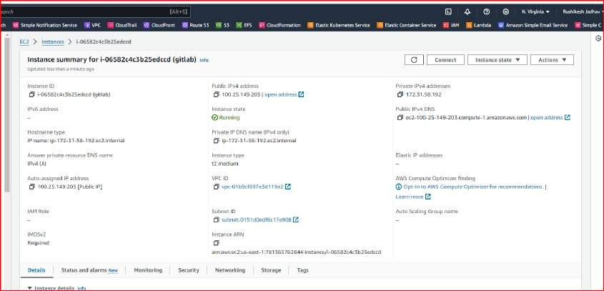

**Security group**



**ECR**

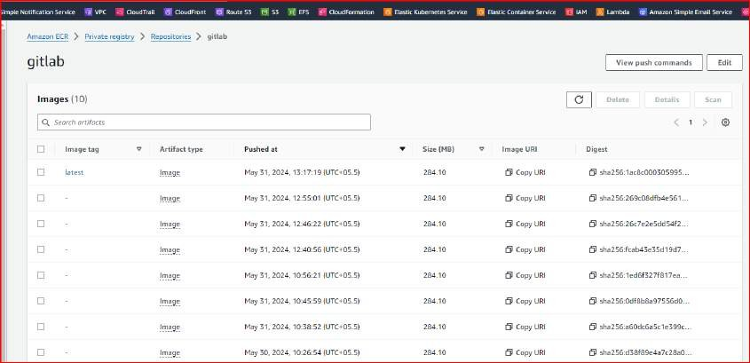

**IAM**

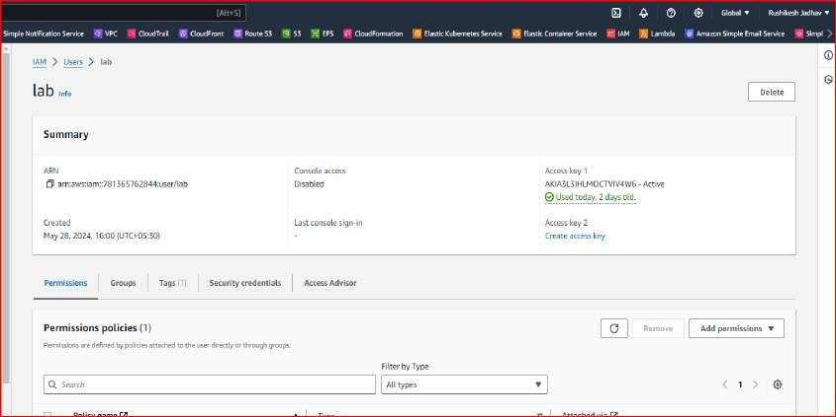

**Import project from GITHUB**

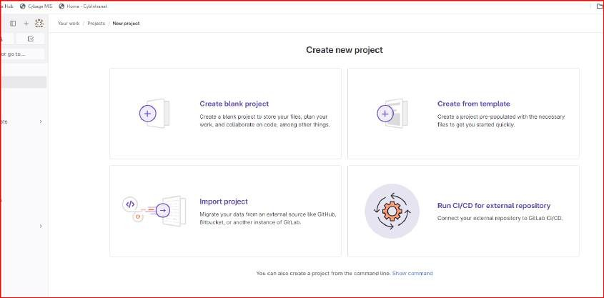

**After that go to project tab on left side and select your project Create .gitlab-ci.yml file inside the project and start writing yml file.**

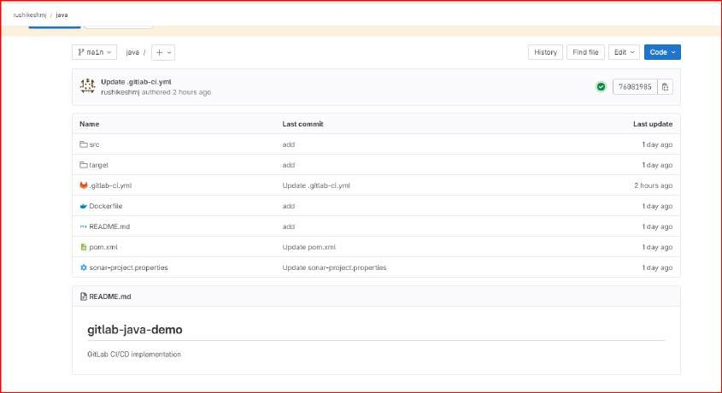

**After doing this install some application on EC2 Console**

sudo apt-get update

sudo apt-get install docker.io sudo su

sudo curl -L --output /usr/local/bin/gitlab-runner https://gitlab-runner- downloads.s3.amazonaws.com/latest/binaries/gitlab-runner-linux-amd64

sudo chmod +x /usr/local/bin/gitlab-runner sudo chmod +x /usr/local/bin/gitlab-runner

sudo useradd --comment 'GitLab Runner' --create-home gitlab-runner --shell /bin/bash sudo gitlab-runner install --user=gitlab-runner --working-directory=/home/gitlab-runner sudo gitlab-runner start

sudo gitlab-runner register

sudo vi /etc/gitlab-runner/config.toml sudo gitlab-runner restart

docker run -d --name sonarcontainer -p 9000:9000 sonarqube docker ps

docker run -d --name jenkinscontainer -p 8080:8080 jenkins/jenkins docker ps

sudo apt-get install -y curl unzip

curl "https://awscli.amazonaws.com/awscli-exe-linux-x86_64.zip" -o "awscliv2.zip" unzip awscliv2.zip

sudo ./aws/install aws --version

aws configure aws login

1. **CI steps for GitLab workflow which includes ( Use Self Hosted Runner )**
   1. **Checkout code to repo**
   2. **Unit testing**

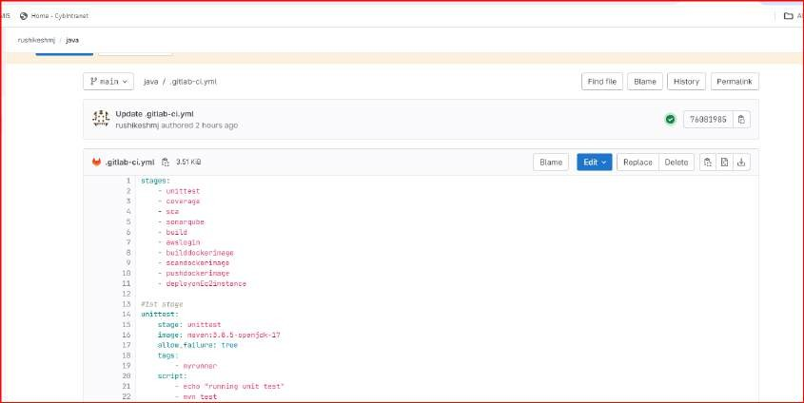

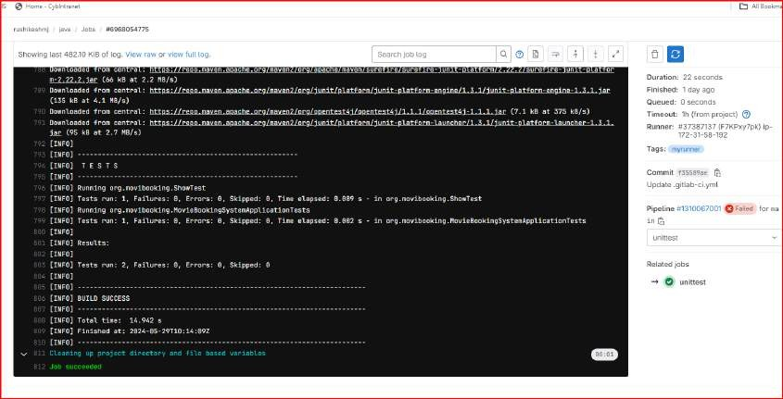

* 1. **code coverage using jacoco**

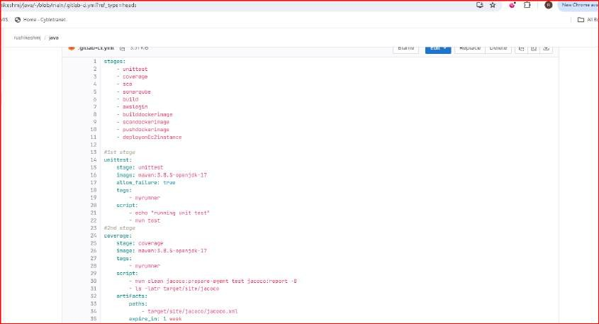

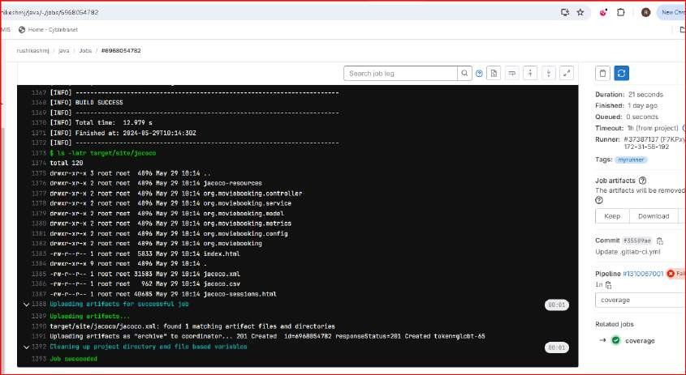

* 1. **SCA using SonarQubes along with quality gates**

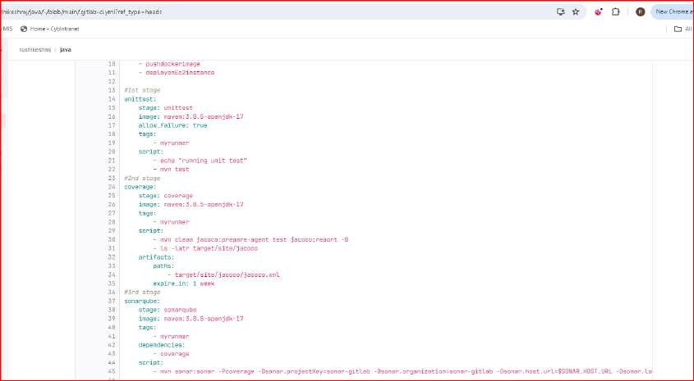

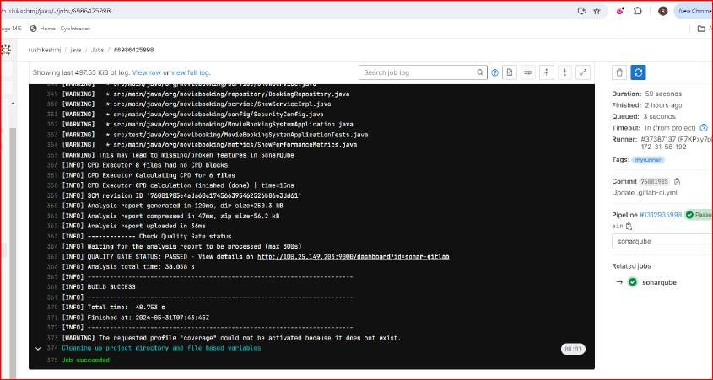

* 1. **Build and package JAR**

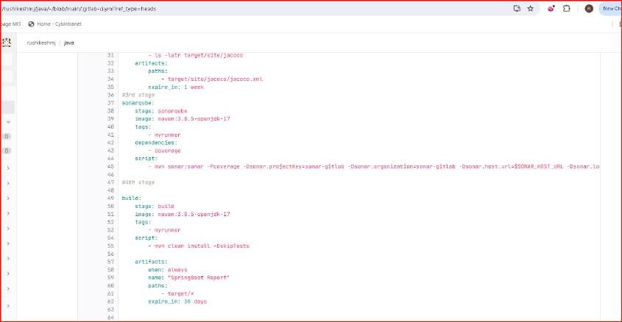

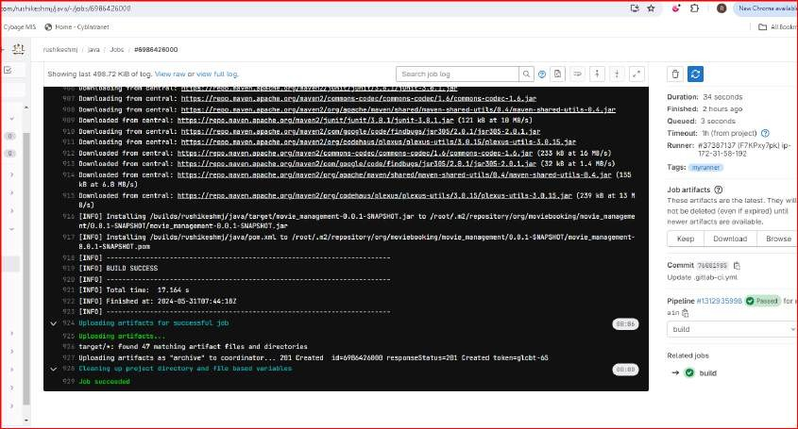

* 1. **Configuration of AWS**

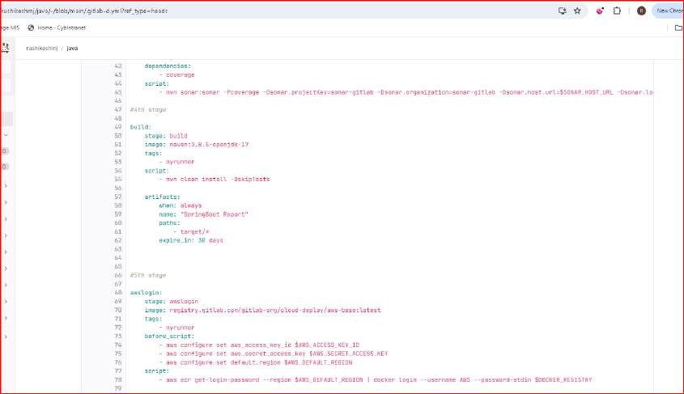

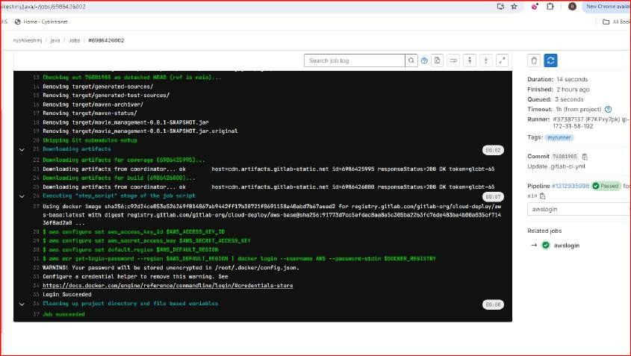

* 1. **builddockerimage**

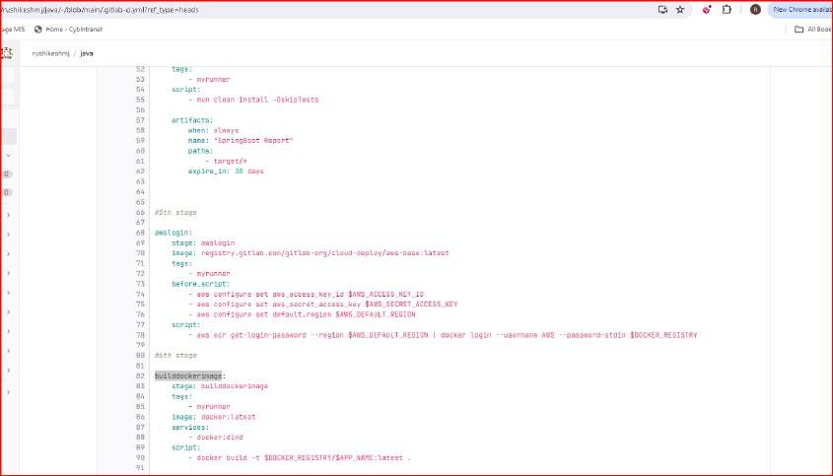



* 1. **scandockerimage**

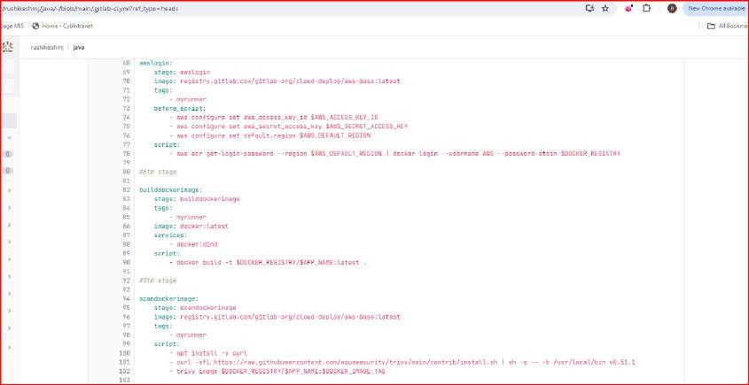

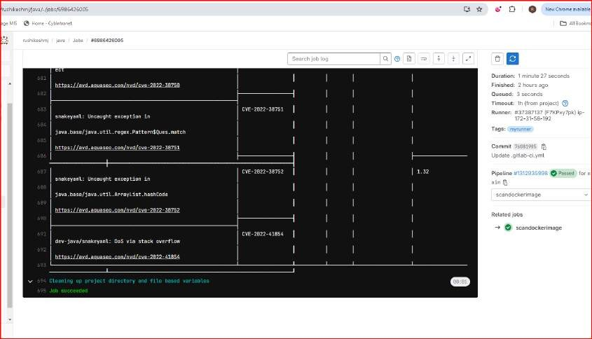

* 1. **pushdockerimage**

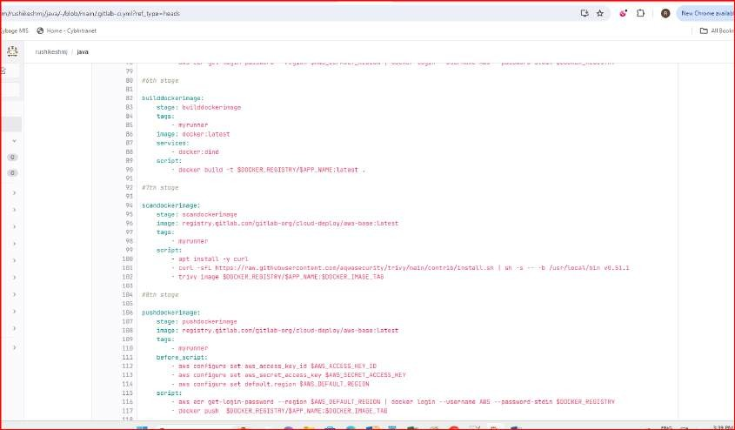

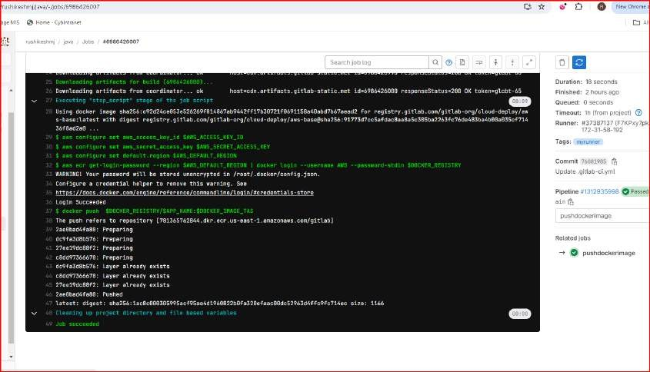

1. **CD steps includes**

**1. Deploy application on EC2 using SSH Private Key**

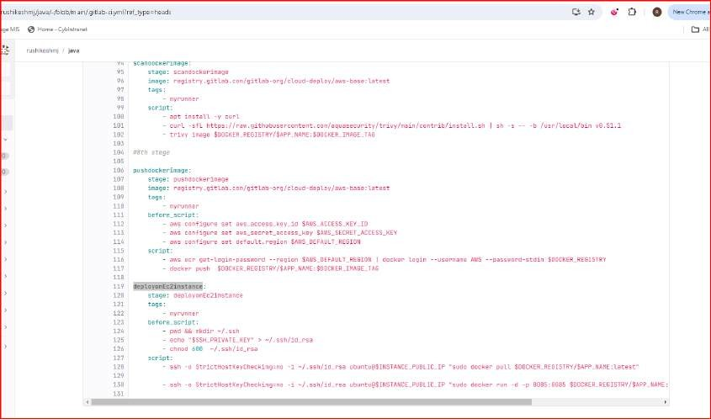

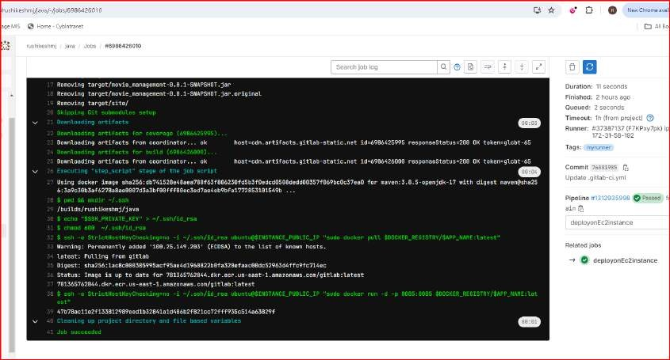

**Complete pipeline**

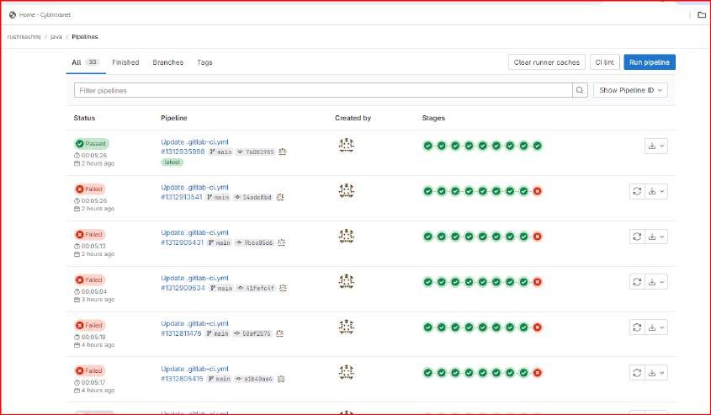

**For above pipeline code we need to set variables in settings--CI/CD-- variables**

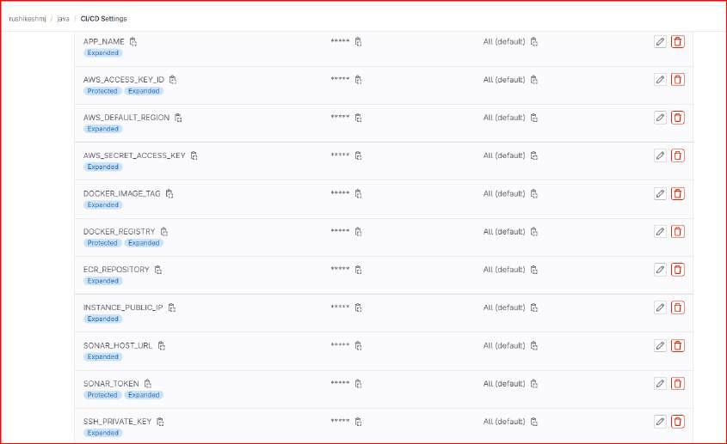

1. **Integration of tools**

**Jenkins GitLab Integration using same GitLab Repo**